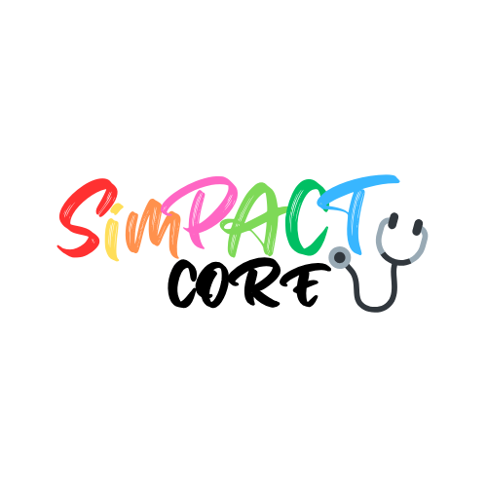

PROGRAMME
Faculty Development in Simulation

08.00 – 08.45 Faculty huddle and brief
08.45 – 09.00 Registration and coffee
09.00 – 09.15 Welcome, introductions and course overview
09.15 – 09.30 What is simulation? An update from the evidence base
09.30 – 10.15 What are the different modalities of simulation-based learning?
‘Hands on’ experience!
10.15 – 10.30 What are the key ‘pedagogical ingredients’ that make a successful sim?
10.30 – 10.45 Break / coffee
10.45 – 12.00 Let’s design a simulation-based learning activity
12.00– 13.00 Effective pre-briefing
13.00 – 13.45 Lunch/Networking
13.45 – 14.45 Effective facilitation in simulation
14.45 – 16.15 Effective debriefing
16.15 – 16.45 Bringing it all together, take aways, next steps, certificates, evaluation

